Merge Files Instructions

## Instructions

App version 1.0

Instructions for “Merge Files application”

**Please read and follow all the instructions for a proper use of application!**

## Prerequisites:

We have to case scenarios:

1. The case where we have multiple excels files with one sheet

and

1. The case where we have one excel file but with multiple spreadsheets.

In the interface it is mandatory to tick the option just in case if you have one document with multiple sheets. Otherwise, do not mark it.

## Instructions:

1. Open the app:

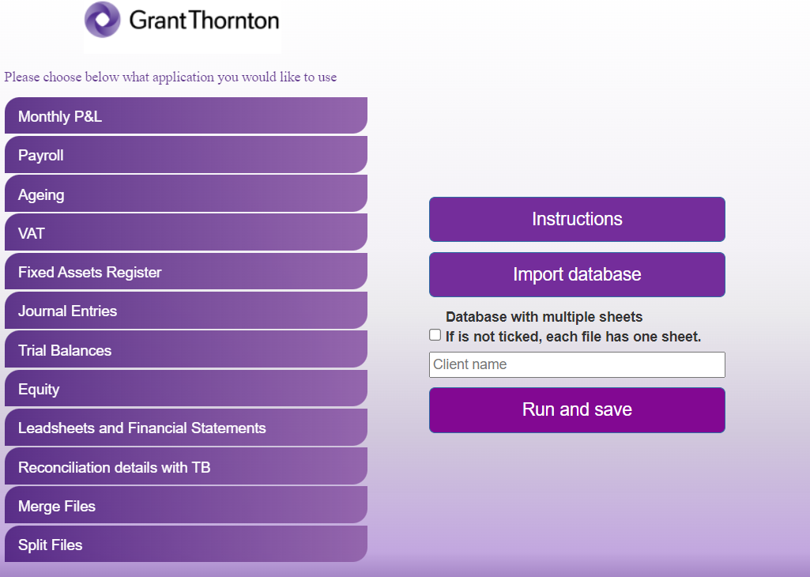

1. Click “Import database” button and select the database/s.
2. Tick the “Database with multiple sheets” if you meet the conditions presented above.
3. In the “Client name” introduce the information accordingly.
4. Click “Run and save”. Once clicking that, the robot will process your request and exit the application.
5. Finally, you should obtain an Excel document named “Database + client name”

Note: Please do not modify any of the templates provided!

For any issues or any other questions or suggestions, please contact:

Cristian Iordache, [cristian.iordache@ro.gt.com](mailto:cristian.iordache@ro.gt.com)

Bogdan Constantinescu, bogdanconstantinescu@ro.gt.com